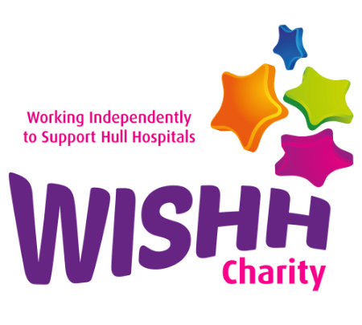
Yorkshire Three Peak Challenge
Horton in Ribblesdale, BD24 0HF
This is your opportunity to take part in a 24-mile circular walk across the Yorkshire Three Peaks offering amazing views and a great team atmosphere. A fully marshalled walk with checkpoints and support from the WISHH Team who will be there to spur you on.
Starting in Horton-in-Ribblesdale, you will begin your journey hiking up Pen-Y-Ghent, past Ribblehead Viaduct to ascend Whernside and finally tackle the short scramble up Ingleborough before heading back into Horton-in-Ribblesdale where we will be waiting to celebrate your return.
It will be an early start with most walkers expected to complete the challenge in 12 hours. You will need to put in the training and once you are signed up, you will receive an in depth information pack.

We are offering two registration options:
Pay a £45 registration fee and then raise as much sponsorship as you can; we ask you aim for a minimum of £130
OR
Self-fund - pay the £45 reg fee, plus a £50 donation and there is no need to worry about sponsorship.
To register please complete the attached registration and medical declaration form.

FAQ's

What does the registration fee include?
- £45 registration fee includes:
- A fully marshalled walk with support which means, we will get you off the mountain if needed or bring you back to the start if you can't finish
- Medal
- Personalised certificate
- Support with setting up a WISHH Three Peaks Just Giving Page to collect donations and share your story. Traditional sponsorship forms also available.
Is the Walk guided?
The walk is marshalled at checkpoints for safety and we have full mountain support from overlimits. We will provide you with a detailed itinerary and kit list upon sign up. You will be responsible for navigating your own way, but there is great signing throughout and you will also receive a detailed instruction sheet upon registration.

Is there an age limit for the walk?
We don't recommend children under the age of 16 taking part in the walk and then they must be accomplished at walking the distance and terrain. We welcome all ages, please just ensure that you are physically fit enough to endure the walk.

How long is the walk?
You will be walking 24 miles on some steep terrain for around 12 hours or more. We aim to set you off around 07:15am and for it to take around 12 hours.

Do I need to bring refreshments?
You should bring 2 litres of water and enough food for a full day on the hills in all weather. Overlimits will provide water top ups at the 10- and 17-mile points. At the 10-mile point there is a sandwich van and at the 17 mile point a barn café.

How fit do I need to be to take on the walk?
All fitness levels are welcome, however we expect walkers to complete the challenge within 12 hours. The amount of training you will need to do will depend on your current level of fitness. If you haven’t exercised for some time, you should seek your GP's advice before starting a new exercise regime.
We suggest that you do some uphill walking in advance! There’s plenty of lovely walks around us and in the Yorkshire Wolds, as well as a bit further away including The Howardian Hills, Sutton Bank, North York Moors and the Cleveland Way have some great inclines.

Are dogs permitted on the walk?
No, dogs a not permitted on the walk. This is in the best interest of the dog, other walkers and the animals in the fields that you will cross.

Are transport or accommodation provided?
No, they are not, but there’s plenty of places to stay nearby. Some entrants may plan on making a weekend of it.

Are there toilets?
Yes, there are toilets in the National Trust Car Park across the road from the registration point and at the 10 and 17-mile points.

Why is there a registration fee?
Your entry fee covers the cost of the marshals, safety support, and medal.
Your sponsorship will also go towards supporting patients, their loved ones and staff across Hull Royal Infirmary and Castle Hill Hospital.

Why is there a self-funded option?
We appreciate that not everyone wants to ask for sponsorship but still want to take part and support us. Upon registration, we will offer you the opportunity to set up a Three Peaks Just Giving Page is you wish to do so.
Is there a minimum fundraising target?
We encourage participants to raise £130, however we understand times are difficult for everyone now and we are hugely grateful to our supporters for taking on this challenge. Raise as much as you can by sharing your fundraising page with friends and family so they can sponsor you.
Can I raise sponsorship offline?
Yes you can. You will receive a sponsorship form upon registration and we can supply you with personalised posters for those local shops and pubs. Get in touch with us and we'll get things ready for you.

What happens once I've signed up?
Once you've signed up to the challenge you will receive your Yorkshire Three Peak welcome and information pack via email. We will support you with a fundraising page link when you register, which means you can start your fundraising right away!
Thank you for finding out further information, if you require anything else, please call 01482 622299 or email Abby/Lisa of the WISHH Charity team hyp-tr.hellowishh@nhs.net
