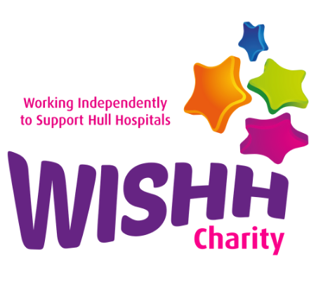

WISHH Working Independently to Support Hull Hospitals
WISHH Charity Office, First Floor - Administration Block, Castle Hill Hospital
Castle Road, Cottingham, HU16 5JQ
T: 01482 622299

Charity Gift Aid Declaration
Boost your donation by 25p of Gift Aid for every £1 you donate. Gift Aid is reclaimed by the charity from the tax you pay for the current tax year. Your address is needed to identify you as a current UK taxpayer.
In order to Gift Aid your donation you must tick the box below:
I want to Gift Aid my donation of £ to: WISHH Charity
✓

Would you like a receipt? Yes No

Please send invoice to me at my address below:
✓
This is a personal donation please claim gift aid on my behalf
I am a UK taxpayer and understand that if I pay less Income Tax and/or Capital Gains Tax in the current tax year than the amount of Gift Aid claimed on all my donations it is my responsibility to pay any difference.
My Details
Title: First name: Surname:
Home address:

Postcode: Date:
Please make cheques payable to “WISHH Charity”. Donations can also be made via Bacs – contact WISHH for details.
Please notify us if you:
- Want to cancel this declaration
- Change your name or home address
- No longer pay sufficient tax on your income and/or capital gains
If you pay Income Tax at the higher or additional rate and want to receive the additional tax relief due to you, you must include all your Gift Aid donations on your Self-Assessment tax return or ask HM Revenue and Customs to adjust your tax code.

